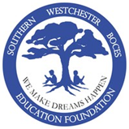
Movember Fundraiser

To raise awareness in support of Men’s Health Issues
NAME:
Dear Potential Sponsor,
I am participating in the Skills USA - Movember fundraiser & competition. All proceeds will help fund Skills USA, the SW BOCES Education Foundation & Prostate Cancer Research. You can sponsor me for any amount you choose & will be entered in support of the above charities. Please make all checks payable to Skills USA.
Fundraiser Details: During the week of November 3rd – 7th, 2014, I will begin clean shaven – and a “before” photo will be taken. I then pledge to grow a mustache (no beards, goat tees, etc.) for the month of November. On November 26, 2014 I will again have my photo taken – either in the Cosmetology classroom or at another location - for entry into a “Best Mustache” competition against the other entrants. BOCES staff and students will be asked to vote on the “Best Mustache” via email and prizes will be awarded to entrants voted as the “Best Mustache” and the winner’s sponsors.
And, may the best mustache win for Skills USA, the BOCES Education Foundation & Prostate Cancer Research
Thank you for your support!
 | Name of Sponsor | Location | Pledge / Donation (Example: $1.00) | Paid? | Check / Cash
1
2
3 | 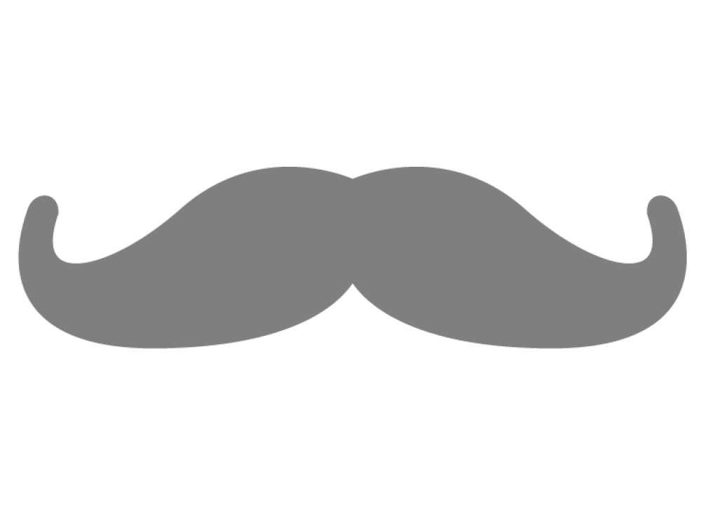
4
5
6
7
8
9
10
11
12
13
14
15

Movember Fundraiser

To raise awareness in support of Men’s Health Issues
The Movember fundraiser is a fun-filled activity & competition open to all Southern Westchester BOCES staff.
Our goal is to raise money to fund Skills USA, the SW BOCES Education Foundation & Prostate Cancer Research while helping to raise awareness of men’s health issues.
Official Rules:
- Entrants will begin during the week of November 3rd – 7th, 2014 clean shaven and pledge to grow a mustache for the month of November in support of the above charities.
- Entrants must send in a completed entry form, the $25.00 entry fee & a “before” photograph – minus any facial hair – before close of business on November 7th. Please email your intent to participate in Movember and a “before” photo to: skranz@swboces.org by close of business on 11/7. The completed Entry Form and a check payable to Skills USA in the amount of $25.00 is to be mailed to:
Center for Career Services
65 Grasslands Road
Valhalla, NY 10595
Attn: Skylar Kranz – Skills USA Advisor

- Entrants are invited to the Cosmetology classroom – Room C 201 – on November 3rd (not required) between 8:00AM and 4:00 PM to officially register, have their “before” photo taken by the Cosmetology students, turn in the Entry Form & pay the entry fee of $25.00 at the Career Services campus.
- For the month of November (11/3 – 11/26/14) the entrant pledges to grow a mustache – no other facial hair - to help raise awareness for Men’s Health issues (no beards, goat tees, etc.)
- The competition ends on Wednesday, 11/26/14 where the entrant must take an “after” photo and send it in via email to skranz@swboces.org by the close of business to be entered in the ‘Best Mustache’ competition. Entrants and staff are again welcome to go to the Cosmetology classroom – Room C 201 – on November 26th between 8:00AM and 4:00 PM to have their official “after” photo taken – light refreshments will be served.
- After the close of the competition on Wednesday, November 26, 2014 – all before & after photos will be compiled and BOCES staff & students will be asked to vote (via email) on the “Best BOCES Mustache.”
- A trophy and prizes will be awarded to the staff member(s) voted as having the Best BOCES Mustache.
- Entrants will also be asked to collect donations from “sponsors” throughout the month of November and record their donations on the attached form. All checks and cash are to be turned in to the Center for Career Services – all checks should be made payable to Skills USA. Sponsors of the winning mustache (and its host sponsoree) will be eligible for prizes as well!
- MOST IMPORTANTLY: Have fun, encourage your coworkers, and may the best ‘stache win...
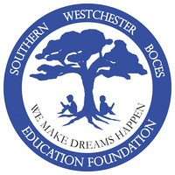
If there are any questions, please contact James Matera, Principal at (914) 761 3400 ext. 223 or via email at jmatera@swboces.org for additional details.
Thank you in advance for your support.

Movember Fundraiser

To raise awareness in support of Men’s Health Issues

Official Entry Form

Name:

Title:

Location:

Phone:

Email:

Please mail completed Official Entry form and entry fee of $25.00 to:
Center for Career Services
65 Grasslands Road
Valhalla, NY 10595
Attn: Skylar Kranz

A “Before” photo must be emailed to skranz@swboces.org before the close of business on 11/7/14 – or the entrant can officially register at the Center for Career Services, Cosmetology classroom – Room C 201 on November 3rd between 8:00AM and 4:00 PM.
*All checks should be made payable to: Skills USA

