SOUTHERN WESTCHESTER  BOCES  TEACHERS ASSOCIATION  Lesa Curtis, President  Box 276  Rye, NY 10580  www.bocesta.org | 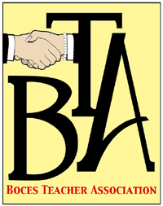

July 15, 2014

Dear Member:
You are eligible to continue some of the insurance coverage your Teachers Association provided to you while you were an active employee. Enclosed you will find important forms and information to continue Life and Accidental Death and Dismemberment (AD&D) Insurance as well as Long Term Care Insurance. This is optional coverage you may purchase at preferred rates. Please note that your coverage provided by the BTA will expire on September 30, 2014. You will have 60 days after September 30th to purchase benefits.
Please review the enclosed material. We encourage you to call UNUM at the numbers listed below if you have any questions or need assistance completing forms. If you are currently purchasing a LTC enhancement through the P&A Group, you must now contact UNAM for direct billing. Your last payment will be withdrawn on the 6th of September for October’s payment.
For Long Term Care Insurance questions please call 1-800-227-4165
For Life and Accidental Death Insurance questions please call 1-800-421-0344
Delta Dental and Davis Vision information regarding cobra options will be mailed to you separately. Please note that the BTA cannot answer any questions regarding your medical or prescription drug coverage.
If you have further questions please contact one of your Benefits Trustees at the email addresses listed below. Please note that the employer section of forms will be completed upon request.
Melissa Barreto - melissabarreto@optonline.net
Sue Carforo – scarforo@verizon.net
Best wishes,

Melissa Barreto

