SOUTHERN WESTCHESTER  BOCES  TEACHERS ASSOCIATION  Melissa Barreto, President  Box 276  Rye, NY 10580  bocesta.net | 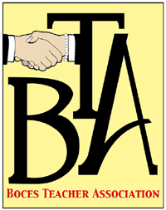

July 1, 2018
Dear
You are eligible to continue some of the insurance coverage your Teachers Association provided to you while you were an active employee. In order to make this process easier, all necessary information and forms are available to you on our website bocesta.net.
Please click on the tab BTA Benefits where you will find the link Retiree-Change in status. Here you will find all the important information and forms needed to continue Life and Accidental Death and Dismemberment (AD&D) Insurance (UNUM). This is optional coverage you may purchase at preferred rates. Please note that your coverage provided by the BTA will expire on September 30, 2018. You will have 60 days from this date to purchase these benefits if you so choose.
We encourage you to call UNUM at the number listed below if you have any questions or need assistance completing forms.
For Life and Accidental Death Insurance questions please call 1-800-421-0344
Delta Dental information regarding cobra options will be mailed to you separately in July from the Wolfpack Insurance Company.
The MetLife Take Along Dental insurance is a benefit offered through SW BOCES and is not affiliated with the BTA. You must contact MetLife directly at 1-844-263-8336 if you have questions.
If you have further questions please contact one of your Benefits Trustees at the email addresses listed below or visit our website bocesta.net and click on the Questions tab. Please note that the employer section of all forms will be completed upon request.
Sincerely,
Benefits Trust Chairperson- Melissa Barreto
president@bocesta.net
Treasurer- Stacey DiPaola
treasurer@bocesta.net
Trustee-Sue Carforo 923-3450
scarforo@verizon.net

